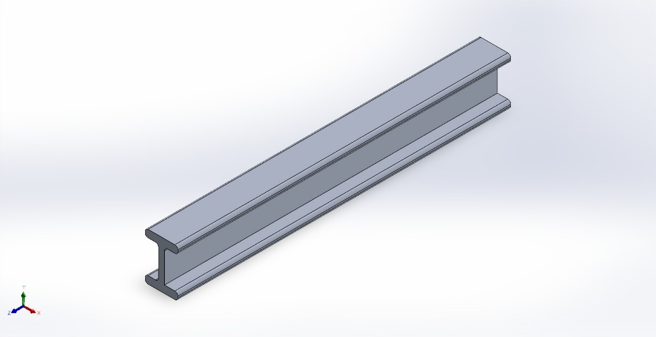 | Simulation of TASK 2 BEAM I  Date: Sunday, May 24, 2026  Designer: Affan Raza  Study name: Static 1  Analysis type: Static  Table of Contents  Description 1  Assumptions 2  Model Information 2  Study Properties 3  Units 3  Material Properties 4  Loads and Fixtures 5  Connector Definitions 5  Interaction Information 6  Mesh information 7  Sensor Details 8  Resultant Forces 9  Beams 9  Study Results 10  Conclusion 12

Description
No Data

Assumptions

Model Information

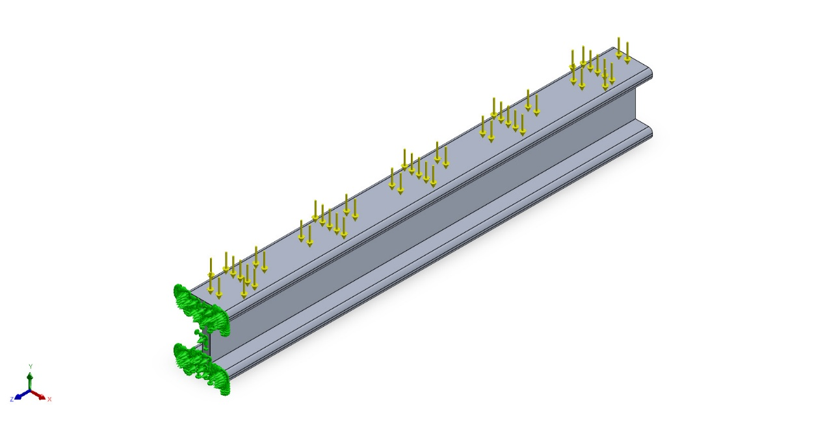
Model name: TASK 2 BEAM I
Current Configuration: Default
Solid Bodies
Document Name and Reference | Treated As | Volumetric Properties | Document Path/Date Modified
Boss-Extrude1  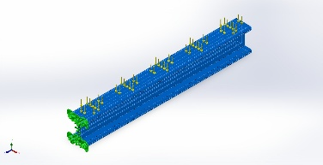 | Solid Body | Mass:22.9603 kg  Volume:0.00850382 m^3  Density:2,700 kg/m^3  Weight:225.011 N | C:\Users\affan\OneDrive\Desktop\TASK 2 BEAM I.SLDPRT  May 24 14:01:38 2026

Study Properties
Study name | Static 1
Analysis type | Static
Mesh type | Solid Mesh
Thermal Effect: | On
Thermal option | Include temperature loads
Zero strain temperature | 298 Kelvin
Include fluid pressure effects from SOLIDWORKS Flow Simulation | Off
Solver type | Automatic
Inplane Effect: | Off
Soft Spring: | Off
Inertial Relief: | Off
Incompatible bonding options | Automatic
Contact penalty stiffness scale factor | 1
Large displacement | Off
Compute free body forces | On
Friction | Off
Use Adaptive Method: | Off
Result folder | SOLIDWORKS document (C:\Users\affan\OneDrive\Desktop)

Units
Unit system: | SI (MKS)
Length/Displacement | mm
Temperature | Kelvin
Angular velocity | Rad/sec
Pressure/Stress | N/m^2

Material Properties
Model Reference | Properties | Components
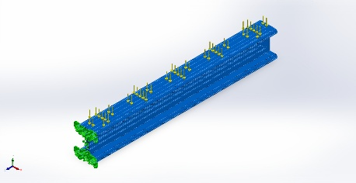 | Name: 1060 Alloy  Model type: Linear Elastic Isotropic  Default failure criterion: Unknown  Yield strength: 2.75742e+07 N/m^2  Tensile strength: 6.89356e+07 N/m^2  Elastic modulus: 6.9e+10 N/m^2  Poisson's ratio: 0.33  Mass density: 2,700 kg/m^3  Shear modulus: 2.7e+10 N/m^2  Thermal expansion coefficient: 2.4e-05 /Kelvin | SolidBody 1(Boss-Extrude1)(TASK 2 BEAM I)
Curve Data:N/A

Loads and Fixtures
Fixture name | Fixture Image | Fixture Details
Fixed-1 | 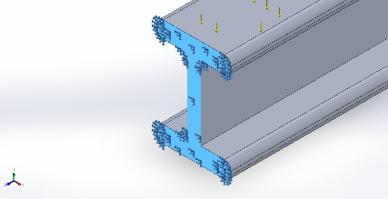 | Entities: 1 face(s)  Type: Fixed Geometry
Resultant Forces
Components | X | Y | Z | Resultant
Reaction force(N) | -0.000371337 | 179.998 | 0.0001297 | 179.998
Reaction Moment(N.m) | 0 | 0 | 0 | 0

Load name | Load Image | Load Details
Force-1 | 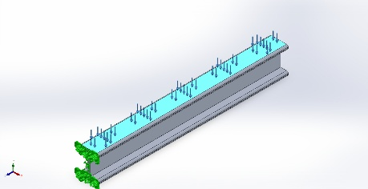 | Entities: 1 face(s)  Type: Apply normal force  Value: 180 N

Connector Definitions
No Data

Interaction Information
No Data

Mesh information
Mesh type | Solid Mesh
Mesher Used: | Blended curvature-based mesh
Jacobian points for High quality mesh | 16 Points
Maximum element size | 20.4146 mm
Minimum element size | 6.80479 mm
Mesh Quality | High

Mesh information - Details
Total Nodes | 92263
Total Elements | 56661
Maximum Aspect Ratio | 4.2382
% of elements with Aspect Ratio < 3 | 99.7
Percentage of elements with Aspect Ratio > 10 | 0
Percentage of distorted elements | 0
Time to complete mesh(hh;mm;ss): | 00:00:06
Computer name:

Mesh Quality Plots
Name | Type | Min | Max
Quality1 | Mesh | - | -
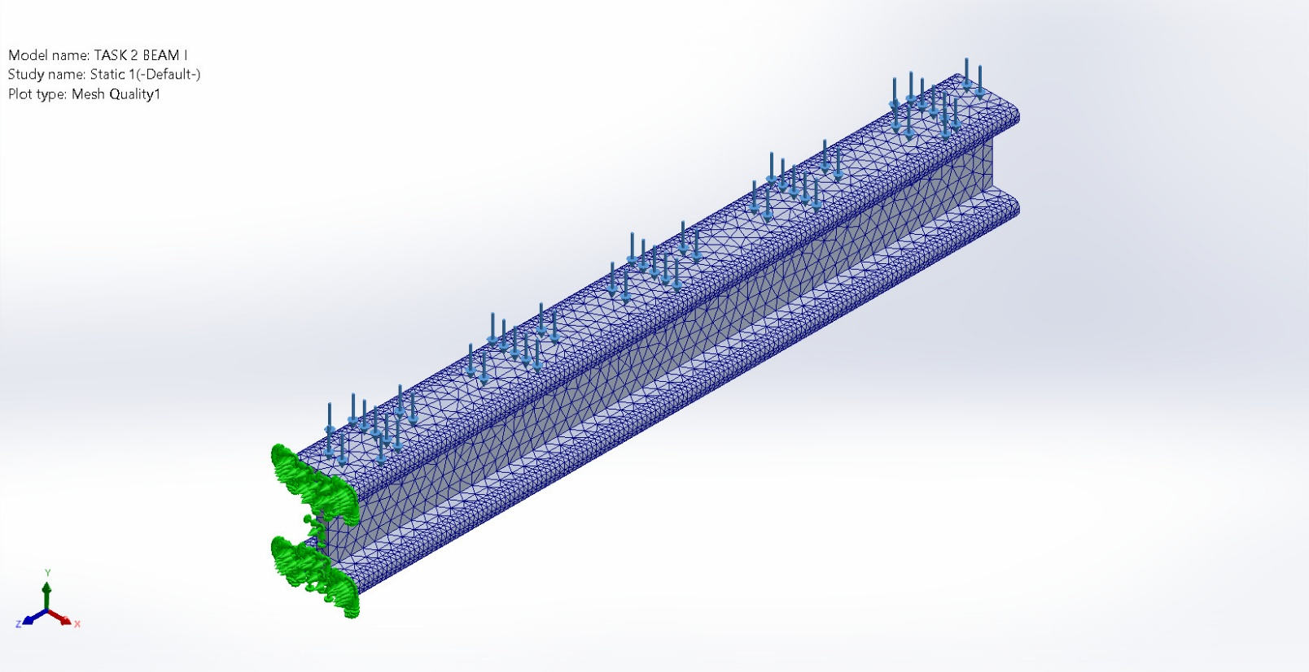
TASK 2 BEAM I-Static 1-Quality-Quality1

Sensor Details
No Data

Resultant Forces

Reaction forces
Selection set | Units | Sum X | Sum Y | Sum Z | Resultant
Entire Model | N | -0.000371337 | 179.998 | 0.0001297 | 179.998

Reaction Moments
Selection set | Units | Sum X | Sum Y | Sum Z | Resultant
Entire Model | N.m | 0 | 0 | 0 | 0

Free body forces
Selection set | Units | Sum X | Sum Y | Sum Z | Resultant
Entire Model | N | -0.0490255 | 0.0424749 | 0.0180672 | 0.0673353

Free body moments
Selection set | Units | Sum X | Sum Y | Sum Z | Resultant
Entire Model | N.m | 0 | 0 | 0 | 1e-33

Beams
No Data

Study Results

Name | Type | Min | Max
Stress1 | VON: von Mises Stress | 2.250e+01N/m^2  Node: 31 | 3.983e+05N/m^2  Node: 91162
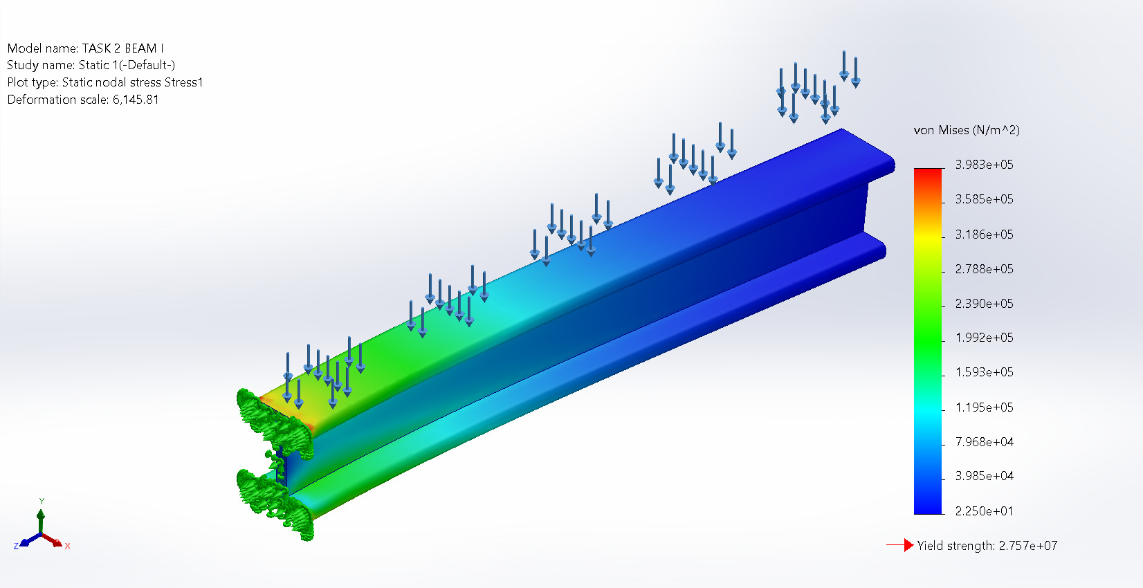
TASK 2 BEAM I-Static 1-Stress-Stress1

Name | Type | Min | Max
Displacement1 | URES: Resultant Displacement | 0.000e+00mm  Node: 3 | 1.829e-02mm  Node: 91884
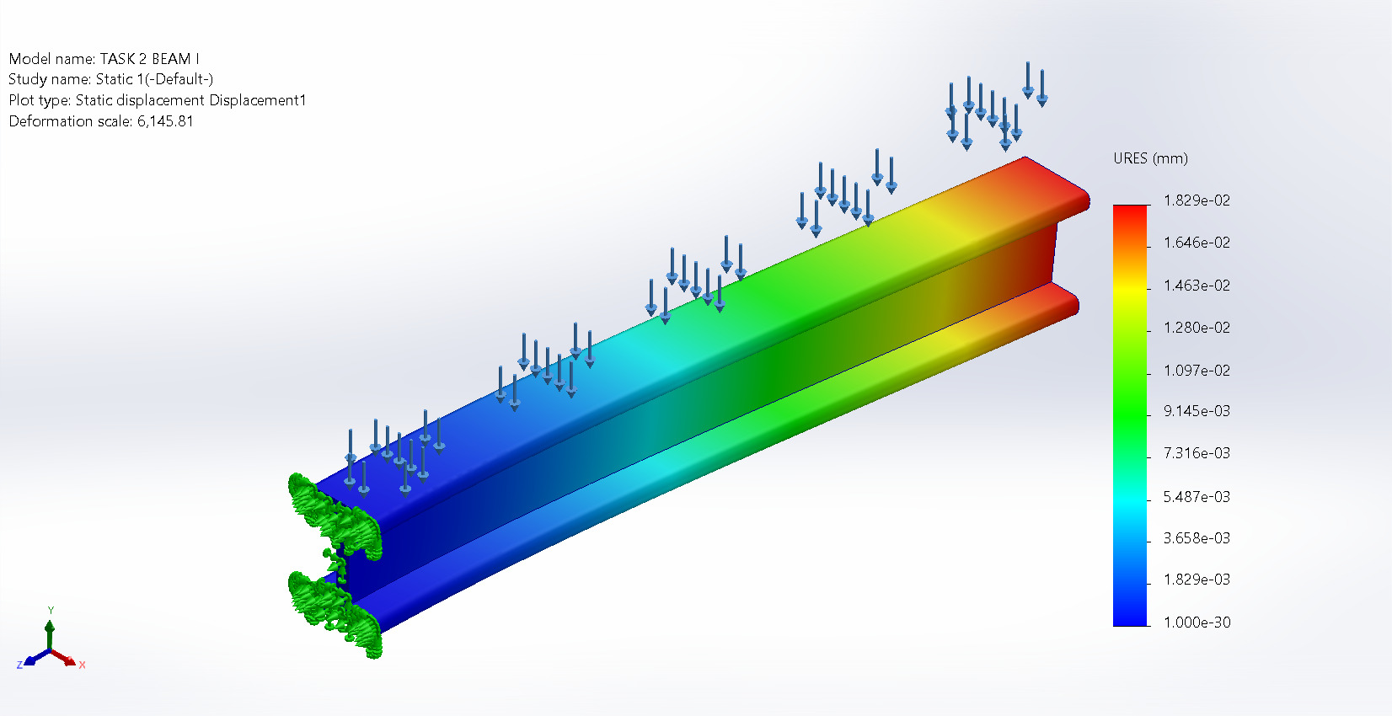
TASK 2 BEAM I-Static 1-Displacement-Displacement1

Name | Type | Min | Max
Strain1 | ESTRN: Equivalent Strain | 5.418e-10  Element: 7746 | 4.573e-06  Element: 45609
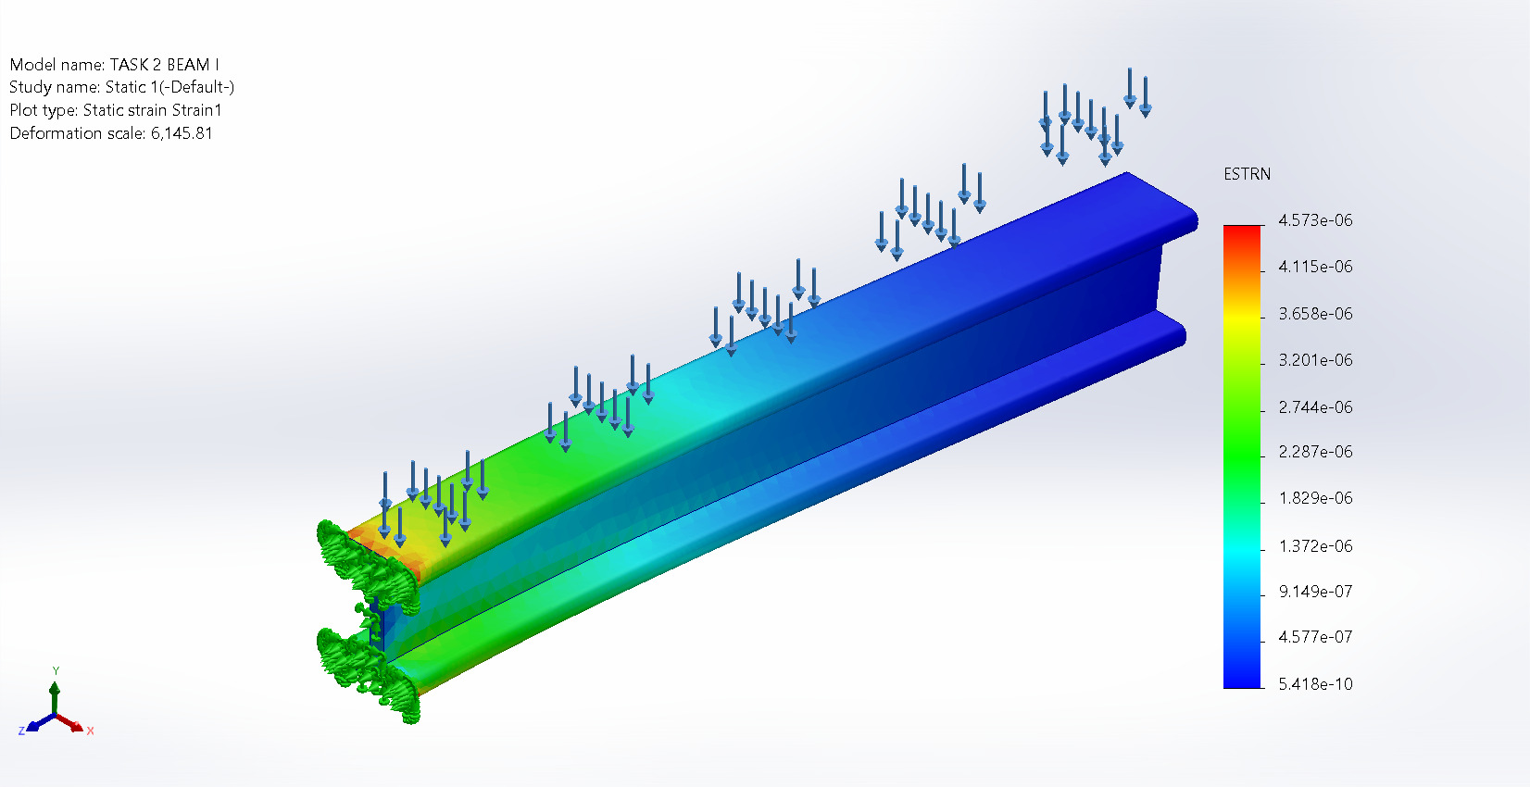
TASK 2 BEAM I-Static 1-Strain-Strain1

Conclusion

